Bahria University

Karachi Campus

COURSE: SEL-448

SOFTWARE APPLICATION FOR MOBILE DEVICES LAB

TERM: SPRING 2024, CLASS: BSE- 6(B)

SUBMITTED BY:

**Ahsan Sajjad**

**79309**

**(Name) (Enrollment No.)**

SUBMITTED TO:

Engr. HAMZA/Engr. ADNAN UR REHMAN

SIGNED REMARKS: SCORE:

INDEX

|  |  |  |  |  |
| --- | --- | --- | --- | --- |
| SNO | DATE | LAB NO | LAB BJECTIVE | REMARKS/SIGN |
| 01 | 16-02-24 | 01 | Introduction To Android Studio (Ide) |  |
|  |  |  |  |  |
|  |  |  |  |  |
|  |  |  |  |  |
|  |  |  |  |  |
|  |  |  |  |  |
|  |  |  |  |  |
|  |  |  |  |  |
|  |  |  |  |  |
|  |  |  |  |  |
|  |  |  |  |  |
|  |  |  |  |  |
|  |  |  |  |  |
|  |  |  |  |  |
|  |  |  |  |  |
|  |  |  |  |  |

Bahria University,

Karachi Campus

LAB EXPERIMENT NO.

01

LIST OF TASKS

|  |  |
| --- | --- |
| TASK NO | OBJECTIVE |
| **01** | Setup Android Studio on your system. |
| **02** | Create a birthday Card Android App using Android Studio in Java language. |
|  |  |
|  |  |
|  |  |
|  |  |
|  |  |
|  |  |

Submitted On:

18-02-2024

(Date: DD/MM/YYYY)

**Task No. 01**: Setup Android Studio on your system.

**Solution:**

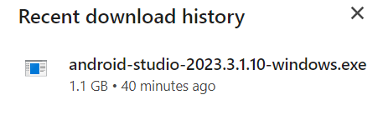

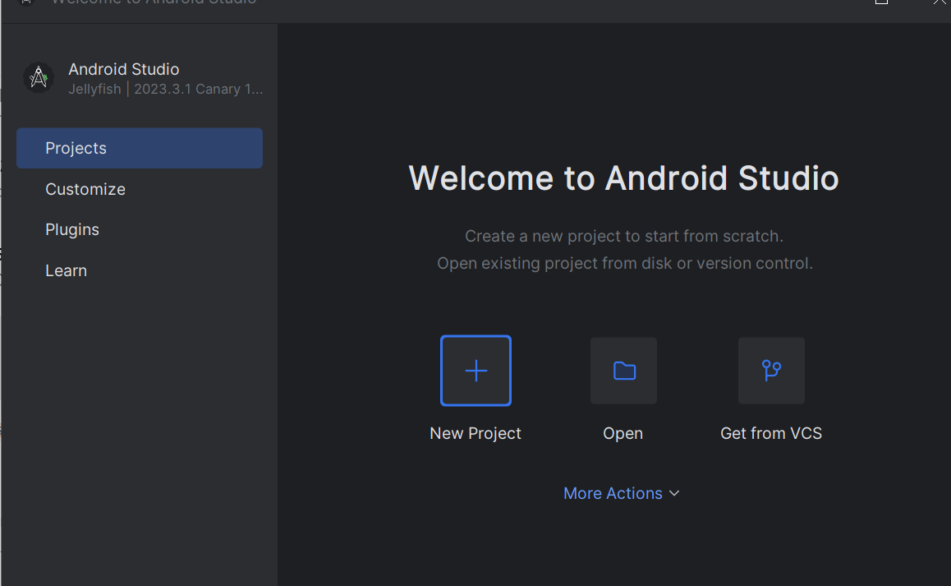

**Task No. 02**: Create a birthday Card Android App using Android Studio in Java language.

**Solution:**

<?xml version="1.0" encoding="utf-8"?>

<androidx.constraintlayout.widget.ConstraintLayout xmlns:android="http://schemas.android.com/apk/res/android"

xmlns:app="http://schemas.android.com/apk/res-auto"

xmlns:tools="http://schemas.android.com/tools"

android:id="@+id/main"

android:layout_width="match_parent"

android:layout_height="match_parent"

tools:context=".MainActivity">

<TextView

android:layout_width="wrap_content"

android:layout_height="wrap_content"

android:text="Ahsan Sajjad "

android:textSize="80px"

app:layout_constraintBottom_toBottomOf="parent"

app:layout_constraintEnd_toEndOf="parent"

app:layout_constraintStart_toStartOf="parent"

app:layout_constraintTop_toTopOf="parent"

app:layout_constraintVertical_bias="0.256" />

<ImageView

android:id="@+id/imageView"

android:layout_width="wrap_content"

android:layout_height="wrap_content"

app:srcCompat="@drawable/happy"

tools:layout_editor_absoluteX="0dp"

tools:layout_editor_absoluteY="25dp" />

</androidx.constraintlayout.widget.ConstraintLayout>

**Output:**